POWER BI DASHBOARD CHALLENGE
TASK 7 – DASHBOARD VISUALIZATION (PART 2)
● Add visuals: ○ Table & Matrix ○ Map, Tree Map, Combo Chart
● Apply conditional formatting and data bars.
● Create hierarchies (e.g., Year → Quarter → Month).
● ✅ Task: Build detailed visuals with drill-down capability.
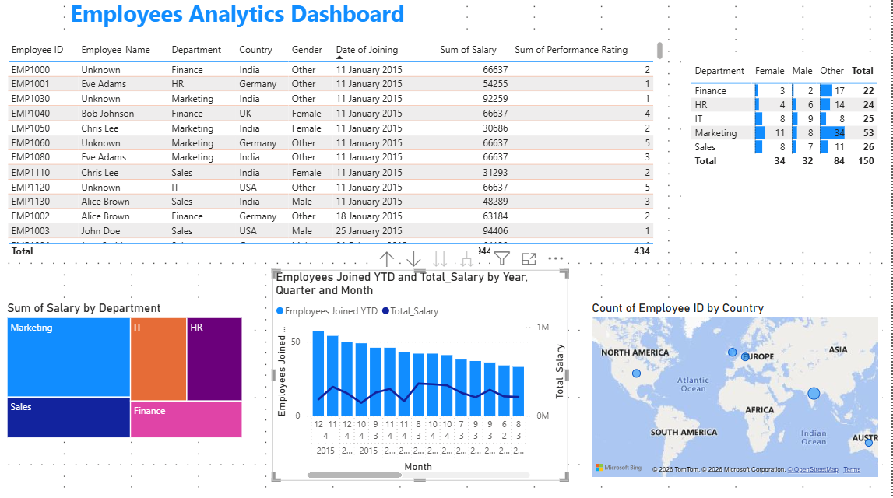
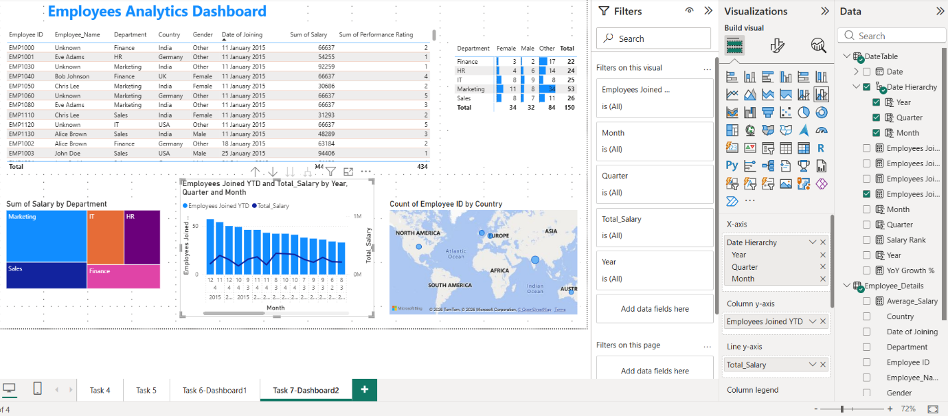

OBSERVATION:
1. A detailed dashboard was created using Table, Matrix, Treemap, Map, and Combo Chart visuals.
2. The Table visual displays complete employee information for detailed analysis.
3. The Matrix visual summarizes employee distribution by department and gender.
4. The Treemap shows the distribution of total salary across different departments.
5. The Map visual displays employee locations by country, providing geographical insights.
6. The Combo Chart compares employee joining trends with salary over time in a single visual.
7. A Date Hierarchy (Year → Quarter → Month) was created to support time-based analysis.
8. Drill-down functionality enables users to explore data from Year to Quarter and Month levels.
9. Conditional formatting and data bars improve the readability of salary values and highlight important information.
10. The dashboard provides an interactive and comprehensive view of employee data, making it easier to identify trends, compare departments, and support data-driven decision-making.

